JavaScript Events

HTML events are **"things"** that happen to HTML elements.

When JavaScript is used in HTML pages, JavaScript can **"react"** on these events.

HTML Events

An HTML event can be something the browser does, or something a user does.

Here are some examples of HTML events:

* An HTML web page has finished loading
* An HTML input field was changed
* An HTML button was clicked

**Types of events in JavaScript**

There are multiple types of events in JavaScript, such as:

mouse events

keyboard events

form events

window events

**JavaScript mouse events**

Several mouse events are available in JavaScript that can be used to react to user interaction with a web page. The following are a few of the most typical mouse events:

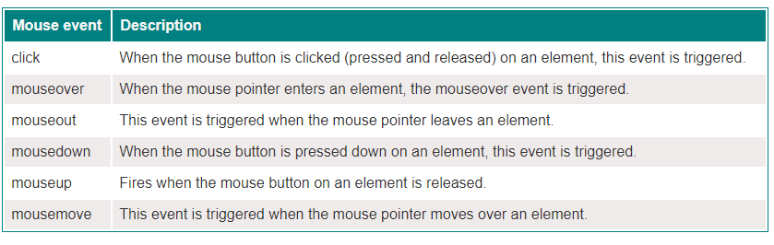

**JavaScript keyboard events**

There are several keyboard events in JavaScript that you can use to detect when a user interacts with the keyboard on a web page. The following table lists and describes the keyboard events in JavaScript:

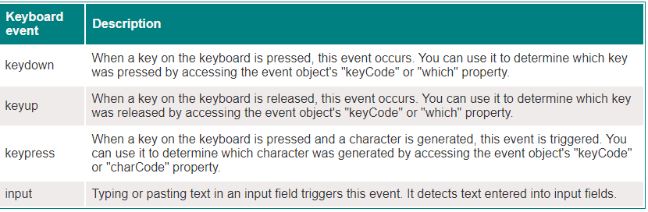

**JavaScript form events**

Several events in JavaScript can be used to monitor changes and interactions with HTML forms. The following table lists and describes the form events in JavaScript:

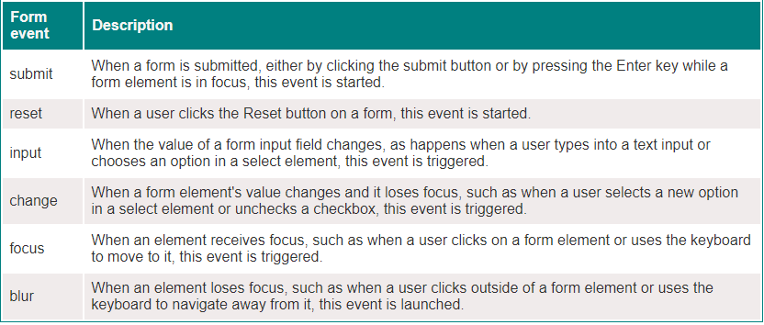

Java Script Window Events

